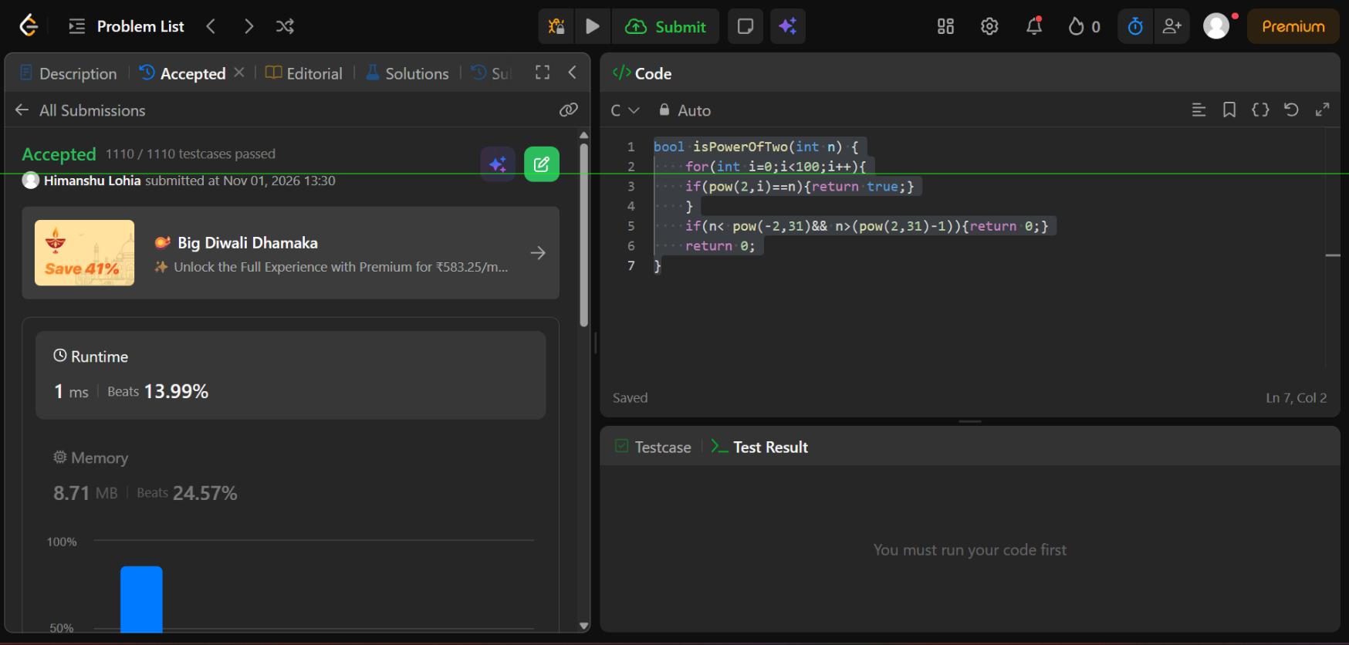
https://leetcode.com/problems/power-of-two/submissions/2186823485/

bool isPowerOfTwo(int n) {
for(int i=0;i<100;i++){
if(pow(2,i)==n){return true;}
}
if(n< pow(-2,31)&& n>(pow(2,31)-1)){return 0;}
return 0;
}

